附件1

图斑1 C4104812010127120098809002

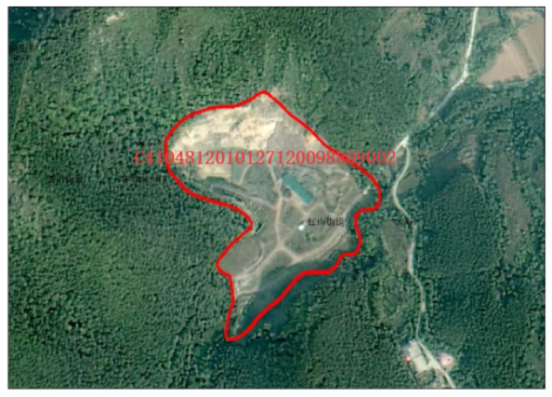图斑2 CT4104812016000001002

